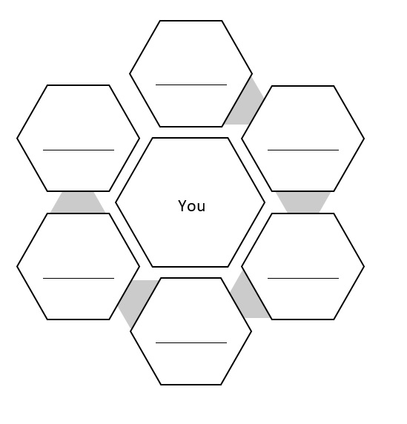

Reflection 3: Illusions of Safety