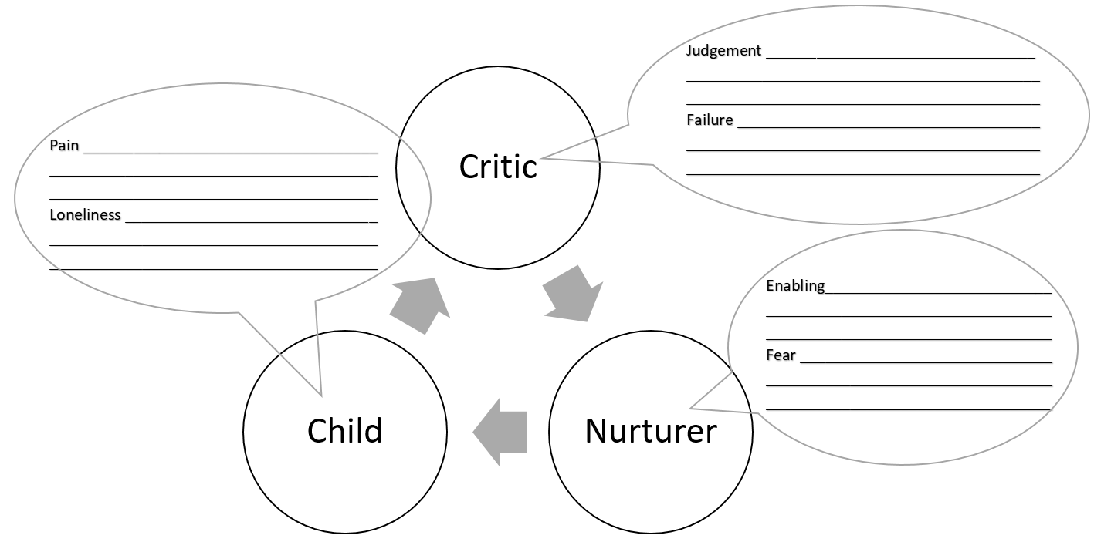

Reflection 6: Our Self Scripts Worksheet