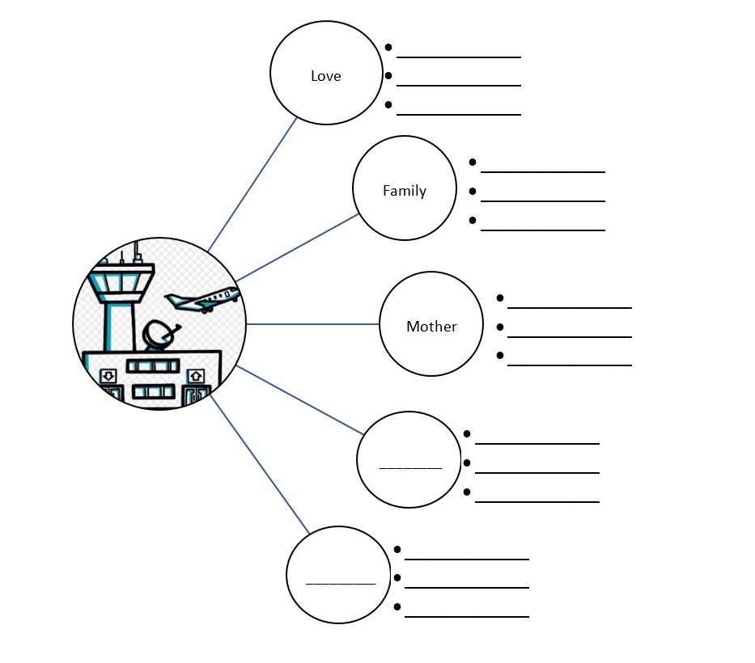

Reflection 2: Brain as an airport